**MaineDOT Machias Middle River Bridge Open House**

**September 14, 2021**



MaineDOT, in cooperation with the Town of Machias, is hosting an open house for the study to identify the preferred alternative for the rehabilitation or the replacement of the existing bridge over the Middle River on Route 1 in Machias. The Town of Machias and others are also using this open house for input on locally sponsored studies. MaineDOT has not made any decision regarding which alternative will move forward into design and construction. The purpose of the open house is as follows:

* Solicit Feedback:
* Current and potential future uses of the bridge and causeway
* Comments, concerns or questions about the alternatives under consideration
* Additional considerations
* Educate and Discuss Options:
* Recent project history and status
* Alternatives under consideration
* Regulatory and decision-making processes

**How to Submit Your Comments to MaineDOT on Machias Middle River Bridge Study**

|  |  |
| --- | --- |
| * Submit Comments in online form or card provided at Open House * E-mail Comments to [martin.rooney@maine.gov](mailto:martin.rooney@maine.gov) * Phone – Martin Rooney 207-624-3317 | * Written comments: * Martin Rooney, Project Manager * MaineDOT, Bureau of Planning * 24 Child Street, 16 State House Station * Augusta, Maine 04333-0016 |

**Recent Project History**

|  |  |
| --- | --- |
| 2018:   * MaineDOT identifies in-kind replacement as preferred alternative   2020:   * National Marine Fisheries Service stated substantial concerns * New legal guidance: MaineDOT/FHWA could compensate landowners impacted by flooding from the project; and * Town of Machias Flood Project could directly impact the culverts/bridge and Route 1 and needs consideration in the design   2021:   * Existing structure continues to deteriorate * March 2021 Virtual Public Meeting * Coordination with the Town of Machias on the Machias Flood Protection Project * Reduced number of alternatives on the matrix by grouping by structure type. To eliminate duplication from previous studies and allows for clearer comparison of potential impacts. * Evaluation of alternatives shifted to box culvert alternatives or bridge alternatives; less preference for in-kind due to potential impacts to Atlantic salmon and its critical habitat. * MaineDOT is committed to understanding current uses of the causeway and investigating culvert/bridge alternatives that maintain or enhance these uses | 2021 cont’d   * Data collection on wells, hazardous materials and waste sites, and tidal exchange continues to refine flooding/property impacts of the boxculvert and bridge alternatives. * Hydraulic modeling refined to characterize fish passage improvements with box culvert and bridge alternatives. * Coordination and technical assistance from NOAA underway to identify potential effects to Atlantic Salmon critical habitat (safe, timely, and efficient fish passage). * Expanded survey of National Register-eligible properties to include areas potentially affected by a bridge alternative and any potential improvements at Stride Bridge. Coordination with Maine Historic Preservation continues, as well as with FHWA Historical and Cultural experts. * Considering feasibility of Sea Level Rise accommodation for bridge and culvert options. * Legal Research underway to understand railroad requirements and design implications for alternatives. * Legal research underway on options for compensation of property owners related to flooding. * Characterize existing uses of the causeway and community needs * Tracking other efforts in the area (Downeast Salmon Federation Schoppee Marsh) |

**Alternatives Under Consideration Summary**

The attached matrix summarizes several alternatives depicted for further study involving both bridges and culverts. Culverts generally provide better control over landward water levels, support a phased approach to Sea Level Rise and are easier to accommodate railroad corridor grade constraints. Bridges better accommodate fish passage and tidal restoration, but have challenges associated with maximum Sea Level Rise accommodation and Route 1 connectivity. While any alternative that moves forward into design will be coordinated with Machias’ Flood Protection Project, the ability to adjust the height of Route 1 over time with culverts could make coordination easier.

**Regulatory and Decision-Making Process Summary**

MaineDOT is continuing to study the alternatives in the above matrix and gather information which will be used in the environmental review process for decision making. MaineDOT anticipates using federal resources to rehabilitate or replace the Machias Middle River Bridge and must follow all applicable state and federal regulatory processes. In particular, the National Environmental Policy Act (NEPA), Endangered Species Act and Section 106 of the Historic Preservation Act will influence how a preferred alternative is selected. The environmental review process is not limited to the natural environment but also includes cultural, social and economic resources as well.

|  |  |  |
| --- | --- | --- |
| ***Natural***   * Fisheries * Wildlife * Coastal Wetland * Tidal Exchange * Climate Change * Sea Level Rise | ***Cultural***   * Historic resources   (racetrack, railroad depot)   * Archaeology * Recreational facilities   (trails, boat launch) | ***Social and Economic***   * Community * Property * Business * Traffic * Utilities * Cost |

NEPA does not require MaineDOT to select an alternative with the least amount of environmental impact and/or any alternative with the lowest cost. NEPA guides the decision-making process which is summarized by the following table: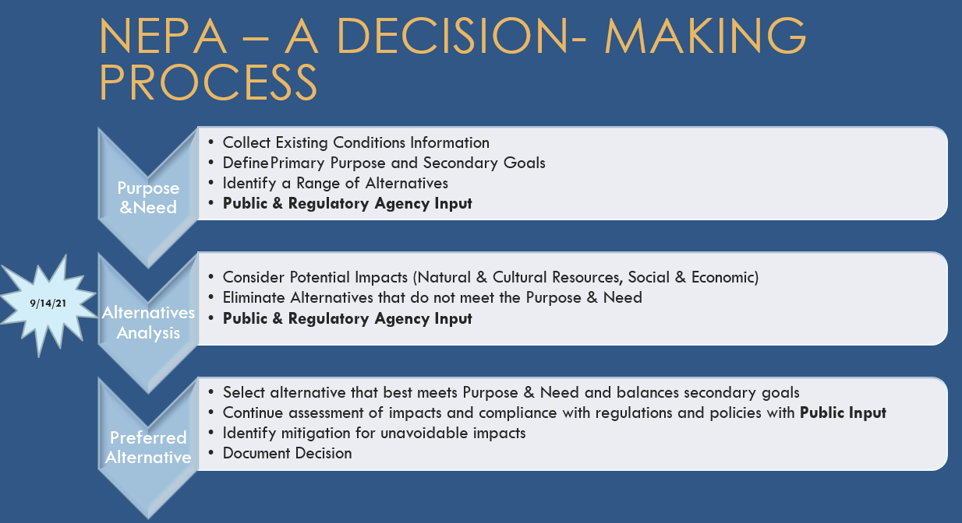

**MaineDOT Project Need Statement (Part of Federal Process Evaluation)**

|  |  |
| --- | --- |
| * Primary * To achieve an overall structure rating of Good (7/9) or better; and * To preserve the Calais Branch Rail Corridor in the area in accordance with the State Railroad Preservation Act. | * Secondary * Maintain existing uses * Municipal coordination including local planning efforts underway * Minimize flooding and impacts * Restore fish passage * Account for Sea Level Rise |